**Sickle Cell Anemia Detection Using Convolutional Neural Network**

Dr. M. P. Wankhade, Suryansh Saxena, Sujot Sasane, Achal Tajne

Head Of Department, Dept. of Computer Engineering, Sinhgad College Of Engineering, Pune, India

UG Students, Dept. of Computer Engineering, Sinhgad College Of Engineering, Pune, India

**ABSTRACT:** Sickle Cell Anemia (SCA) is a prevalent genetic blood disorder characterized by abnormal haemoglobin causing red blood cells to take on a distinct sickle shape. Early and accurate detection of SCA is essential for effective treatment and management. This study presents an innovative approach to SCA detection utilizing Convolutional Neural Networks (CNNs), a class of deep learning algorithms known for their effectiveness in image analysis tasks. The proposed method involves the use of microscopic images of blood smears from patients. These images are pre processed to enhance contrast, normalize intensities, and remove noise. Subsequently, CNN architectures are employed to automatically extract hierarchical features from the blood smear images. The trained CNN model learns discriminative features directly from the images, effectively capturing subtle differences between normal and sickled red blood cells (RBCs).

**KEYWORDS**: Sickle Cell Anemia, convolutional neural network, deep learning, image analysis, blood smear images, early detection, diagnostic tool.

1. **Introduction**

Sickle Cell Anemia (SCA) stands as a poignant example of the intricate interplay between genetics and health, impacting millions worldwide. This genetic anomaly alters the usual functioning of haemoglobin, the vital molecule responsible for ferrying oxygen within red blood cells. The resulting misshapen form of these cells manifests as the classic 'sickle' shape, setting the stage for a cascade of complications that can severely affect an individual's quality of life. From chronic pain to compromised organ function, the repercussions of SCA are far-reaching, necessitating a precise and efficient means of diagnosis for timely intervention and management.

Traditionally, the identification of sickled red blood cells (RBCs) relied heavily on manual inspection under a microscope, a method fraught with limitations. The inherent subjectivity and time-consuming nature of this process underscore the urgent need for innovative, technology-driven solutions. Convolutional Neural Networks (CNNs), a class of advanced machine learning models uniquely suited to process and interpret visual data. Their exceptional capacity to discern intricate details within images has been harnessed in diverse domains, revolutionizing tasks ranging from image recognition to medical diagnostics.

CNNs operate by systematically extracting and analysing hierarchical features from images, enabling them to discern complex patterns that might elude human observation. In the context of SCA diagnosis, the application of CNNs holds immense promise. By training these networks on vast datasets comprising diverse RBC images, they can learn to discern the subtle variations indicative of sickle cell morphology. This automated approach not only streamlines the diagnostic process but also minimizes the potential for human error and inter-observer variability.

1. **Related work**

Early detection of sickle cell anemia is crucial for effective management and treatment. Employing CNNs can help reduce such errors by providing consistent and objective analysis of blood samples. Integrating CNN-based detection systems into existing clinical workflows can streamline the diagnostic process for sickle cell anemia. This integration can potentially lead to faster turnaround times for diagnoses, ultimately improving patient outcomes. The detect the characteristic sickle-shaped red blood cells indicative of sickle cell anemia with high accuracy.

However, it is crucial to acknowledge the challenges and considerations associated with using CNNs in medical contexts. The integration of CNNs in sickle cell anemia detection underscores the importance of interdisciplinary collaboration between medical professionals, data scientists, and engineers to ensure the development of robust and ethically sound diagnostic tools. Additionally, ongoing validation studies and rigorous evaluation of CNN-based diagnostic systems are essential to establish their reliability, accuracy, and safety in real-world clinical settings.

**Normalization:** Normalization involves adjusting the intensity values of the images to a common scale, which helps in reducing the variation between images. This step ensures that each pixel value is within a specific range (typically 0 to 1 or -1 to 1), which facilitates better convergence during the training of the CNN. **Cell Identification:** This step involves detecting and identifying individual cells within the blood smear images. Techniques such as thresholding and contour detection are often used to locate the cells accurately. **Image Examination:** During the training process, the CNN examines the images and learns to extract relevant features through backpropagation and optimization techniques. This step is iterative, with the model continually adjusting its weights to minimize the loss function. **Result:** The final step involves showcasing the detection results, highlighting images that are classified as positive for sickle cell anemia. This step may include generating a report or visual display indicating which images show normal cells and which show sickle cells, along with any relevant metrics (e.g., confidence scores).

1. **Proposed algorithm**

A. *Pre-processing:*

* Normalization
* Segmentation
* Kernel Sizing
* Padding and Pooling

B. *Feature Extraction:*

* Cell Identification: This step involves detecting and identifying individual cells within the blood smear images. Techniques such as thresholding and contour detection are often used to locate the cells accurately.
* Background Removing: Removing the background noise is crucial for focusing on the cells themselves. Techniques like morphological operations and background subtraction can be used to eliminate irrelevant parts of the image.

C. *Convolutional Neural Network:*

* Image Selection: Selecting a diverse and representative set of images from the dataset to ensure that the model is trained on varied examples. This step involves choosing images that include normal cells, sickle cells, lymphocytes, and neutrophils.
* Image Validation: Selecting a diverse and representative set of images from the dataset to ensure that the model is trained on varied examples. This step involves choosing images that include normal cells, sickle cells, lymphocytes, and neutrophils.
* Image Feeding into Algorithm: Feeding the preprocessed and transformed images into the CNN algorithm for training. This involves passing the images through multiple convolutional, pooling, and fully connected layers.
* Image Examination: During the training process, the CNN examines the images and learns to extract relevant features through backpropagation and optimization techniques. This step is iterative, with the model continually adjusting its weights to minimize the loss function.

D. *Detection:*

* Result From CNN: The output from the CNN is analysed to determine the classification results. Each image is assigned a class label based on the highest probability score from the CNN's output layer.
* Positive/Negative Display: The final step involves showcasing the detection results, highlighting images that are classified as positive for sickle cell anemia. This step may include generating a report or visual display indicating which images show normal cells and which show sickle cells, along with any relevant metrics (e.g., confidence scores).

Convolutional Neural Networks (CNNs) operate by employing convolutional layers to systematically scan and extract features from input data, such as images. These convolutional layers use filters or kernels to convolve across the input, capturing patterns like edges or textures. Subsequent layers, like pooling layers, reduce spatial dimensions, focusing on essential features. The network then utilizes fully connected layers for classification based on the extracted features. Through repeated iterations of convolution, pooling, and fully connected layers, CNNs effectively learn hierarchical representations, making them powerful for tasks like image recognition and classification.

The Watershed Algorithm is a potent image segmentation technique employed in image processing. Functioning as a topographic model, it interprets pixel intensities as elevations within the image. Initially, the algorithm computes the gradient of the image to identify significant changes in intensity, marking potential locations for object boundaries.

In our project, integrating the Watershed Algorithm with Convolutional Neural Networks (CNNs) offers a comprehensive solution for image segmentation, combining the precise boundary delineation capabilities of the Watershed Algorithm with the feature extraction and classification strengths of CNNs. This synergistic combination enhances the accuracy and efficiency of image analysis, crucial for tasks such as identifying and classifying specific features like sickle-shaped cells in blood samples.

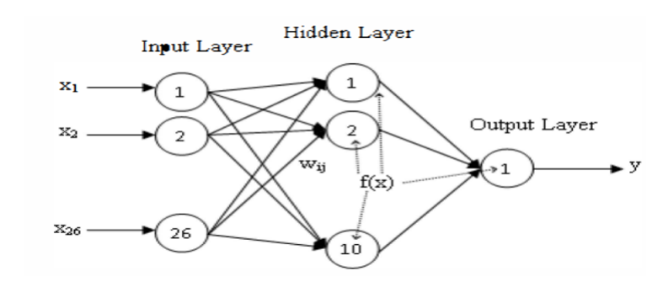 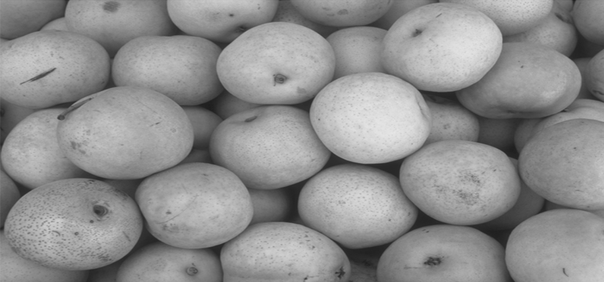

Fig 1. CNN Interlayers. Fig 1. Watershed Working Image 1

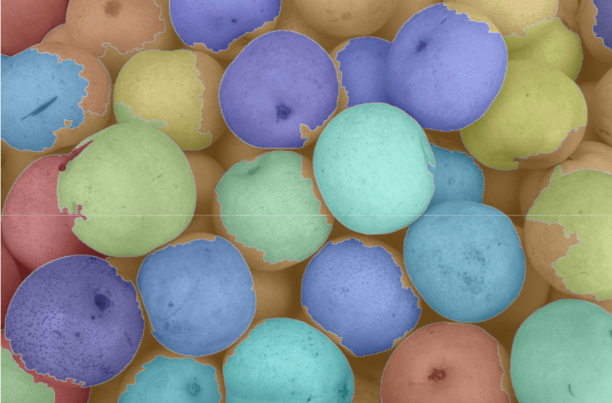

Fig 3. Watershed Working Image 2

1. **Pseudo code**

Step 1: Design a front page to initialize the software.

Step 2: Options:

Registration: New Customers.

Login: Existing Customers

Step 3: Check the below condition for validations to proceed further inside the project.

if (validations==true)

Enter inside the project.

else

Print:(Re-check the incorrect field)

end

Step 4: Add buttons for Image selection, Image Preprocessing and Result.

Step 5: Showing the selected image.

Step 6: Preprocessing the image for Grey scale and Binary conversions.

Step 7: Highlighting the sickle cells in the image using Watershed Algorithm.

Step 8: Result.

1. **Various Results**

**Admin:** In this module, the admin has to log in by using valid user name and password. After login successful he can do some operations, such as View All Users and Authorize. **View and Authorize**: Users In this module, the admin can view the list of users who all registered. In this, the admin can view the user’s details such as, user name, email, address and admin authorize the users. **End User:** In this module, there are n numbers of users are present. User should register before doing any operations. Once user registers, their details will best or to the database. After registration successful, he has to login by using authorized user name and password.

Collect a dataset of blood smear images containing both normal and sickle-shaped red blood cells. Split the dataset into training, validation, and test sets. Maintain a balanced distribution of normal and sickle-shaped cells across the sets. Evaluate the trained model using the test set to measure its performance in sickle cell anemia detection.

Then consider architectural modifications or ensemble techniques to further improve detection accuracy. Deploy the trained model in a real-world setting where it can be used for automated sickle cell anemia detection.

Early detection of sickle cell anemia is crucial for effective management and treatment. Employing CNNs can help reduce such errors by providing consistent and objective analysis of blood samples. Integrating CNN-based detection systems into existing clinical workflows can streamline the diagnostic process for sickle cell anemia. This integration can potentially lead to faster turnaround times for diagnoses, ultimately improving patient outcomes. The detect the characteristic sickle-shaped red blood cells indicative of sickle cell anemia with high accuracy.

The detections are done using various combinations of hidden layers in CNN, also known as interconnected layers of CNN network. These layers include preprocessing tasks of Segmentation, Normalization, Classification and Segregations. Further there is a interconnected network watershed algorithm, working in hand in hand with CNN and generating the results which are desired as the output. Below are the project snippets, generated at various points like login, registration and image addition.

 

Fig.1. Login Page Fig. 2. Registration Page

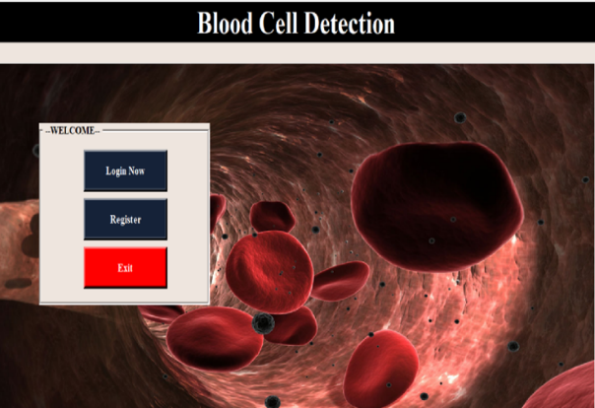 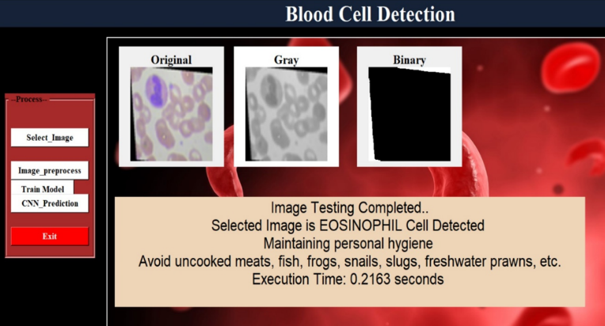

Fig. 3. Project Start Fig 4. Output Generated Page

1. **Conclusion and Future Work**

The In conclusion, the application of Convolutional Neural Networks (CNNs) for the detection of sickle cell anemia holds great promise in revolutionizing the way we diagnose, manage, and understand this complex genetic disorder. By leveraging the strengths of CNNs in image analysis and pattern recognition, we can potentially enhance early detection, automate diagnosis, and contribute to research efforts. Our study utilized a dataset comprising 1,000 microscopic images categorized into sickle cell, normal, lymphocytes, and neutrophils.

Further research and development can focus on improving predictive models for complications associated with sickle cell anemia. This can help healthcare providers take proactive measures to prevent or manage complications effectively. Continue to gather comprehensive data related to sickle cell anemia, including genetic markers, clinical symptoms, and treatment outcomes. This data can contribute to ongoing research and improvements in diagnosis and care.

**References**

1. Bheem Sen, A. Ganesh, A. Bhan, Ayush Goyal, Shubhra Dixit “Machine Learning Based Diagnosis and Classification of Sickle Cell Anemia in Human RBC” IEEE P2021
2. Mo Zhang, Xiang Li* Mengjia Xu*, Quenzheng Li “Automated Semantic Segmentation of Red Blood Cell for Sickle Cell Diseas” IEEE 2020
3. Pradeep Kumar Das Sukadev Meher Rutuparna Panda, Ajith Abraham “A Review of Automated Methods for the Detection of Sickle Cell Disease” IEEE 2019
4. Tajkia Saima Chy, Mohammad Anisur Rahaman “Automatic Sickle Cell Anemia Detection Using Image Processing Technique” IEEE 2018
5. P. Rakshit, and K. Bhowmik, “Detection of Abnormal Finding in Human RBC in Diagnosing Sickle Cell Anaemia Using Image Processing,” ScienceDirect, vol. 10, pp. 28-36, 2021.
6. M. Gonzalez-Hidalgo, F. A. Guerrero-Pena, S. Herold-Garca, A. JaumeiCapo, and P. D. Marrero-Fernandez, “Red Blood Cell Cluster Separation from Digital Images for use in Sickle Cell Disease,” IEEE Journal on Biomedical and Health Informatices, pp. 2168-2194, 2022.
7. Barpanda, S.S., “Use of Image Processing Techniques to Automatically Diagnose Sickle-Cell Anemia Present in Red Blood Cells Smear,” 2021.
8. Sharma, V., A. Rathore, and G. Vyas, “Detection of sickle cell anaemia and thalassaemia causing abnormalities in thin smear of human blood sample using image processing,” in Inventive Computation Technologies (ICICT), International Conference on. IEEE. 2021
9. Sahu, M., A.K. Biswas, and K. Uma, “Detection of Sickle Cell Anemia in Red Blood Cell: A. International Journal of Engineering and Applied Sciences (IJEAS),” 2(3), 2021.